GoLarge

Praying Boldly, Transforming Globally.

**Vision Statement — GoLarge Global Mandate**

To raise a generation of Kingdom-minded leaders who transform nations through prophetic insight and intercession for future generations — repairing broken cities, rebuilding destinies, and revealing God’s glory in every sphere of influence**.**

***Empowering Kingdom leaders to see prophetically, lead purposefully, and transform generations.***

**Mission Statement — GoLarge Global Mandate**

To empower believers to discover their divine assignment, cultivate prophetic understanding, and intercede for generational transformation. Through teaching, leadership development, and apostolic movements, we equip Kingdom leaders to restore broken systems, influence culture, and manifest God’s glory in every nation.

**Core Pillars of the Mandate:**

1. **Vision:** Birthing divine ideas and guiding destinies through revelation**.**
2. **Transformation:** Raising leaders who embody Kingdom culture andcharacter.
3. **Intercession:** Standing in the gap for nations, territories, and generations**.**
4. **Leadership:** Equipping men and women to lead with integrity, wisdom, and excellence.
5. **Impact:** Turning spiritual fire into tangible societal change.

**Scriptural Foundation:**

*“You shall be called the repairer of the breach, the restorer of streets to dwell in.”* — Isaiah 58:12  
*“The earth shall be filled with the knowledge of the glory of the Lord as the waters cover the sea.”* — Habakkuk 2:14

**About GoLarge Global Mandate**

GoLarge Global Mandate is a divine movement dedicated to raising a generation of Kingdom-minded leaders who will transform nations through prophetic insight, strategic leadership, and intercession for the next generation. The mandate carries a burden to repair broken cities, rebuild destinies, and reveal God’s glory across every sphere of influence — from governance and business to education, culture, and ministry.

At its core, GoLarge is not just an organization; it is a spiritual call to national transformation. It equips believers to see beyond the ordinary, act with divine purpose, and manifest the realities of the Kingdom of God in the earth. Through prayer altars, leadership summits, and global missions, GoLarge inspires individuals to live with vision, serve with excellence, and influence society with the wisdom and power of the Holy Spirit.

In essence, the GoLarge Global Mandate is a movement to raise reformers, rebuild nations, and release God’s glory to the world.

**GIVE — You’re not losing; you’re planting**

There was once a farmer who loved his land. Every year, he planted his best seeds, not the leftovers. His neighbors often mocked him, saying, “Why waste the best? Keep the finest for yourself.”

But he always smiled and said, “I’m not losing seed; I’m planting a future.”

One year, a drought came. Fields all around him dried up, but his crops still grew — strong, green, and fruitful. His secret? The good seed he had sown in faith had deeper roots.

That’s how giving to God works. When you give, you’re not losing; you’re planting into soil that never fails. Every seed you release creates a future you cannot yet see — in opportunities, favor, peace, and generations to come.

As Jesus said in Luke 6:38, *“Give, and it will be given to you; a good measure, pressed down, shaken together, and running over.”*

Your giving is not subtraction — it’s multiplication in disguise.



**Become a Monthly Partner**

You are invited to partner with a Kingdom movement that is shaping the future and birthing transformation across nations. As a monthly partner, you are not just giving—you are sowing into a divine mandate to raise prophetic leaders, repair broken cities, and reveal God’s glory in every sphere of influence.

Your partnership empowers us to equip men and women to see prophetically, lead purposefully, and transform generations. Together, we are advancing the Kingdom of God—one life, one city, and one nation at a time.

Thank you for aligning your seed with this prophetic vision. Every monthly contribution helps us carry the message of hope, healing, and restoration to the nations. May your giving become a voice in the spirit that speaks abundance, open doors, and divine favor over your life.

As you partner with GoLarge, may you partake of the same grace, divine insight, and supernatural increase that rests upon this global mandate.

Please fill out this partnership form

<https://forms.gle/zHPxcyqGV8EruD4X7>

**20 Years of Prayer Investment — It’s Time to Impart Generational Blessings!**

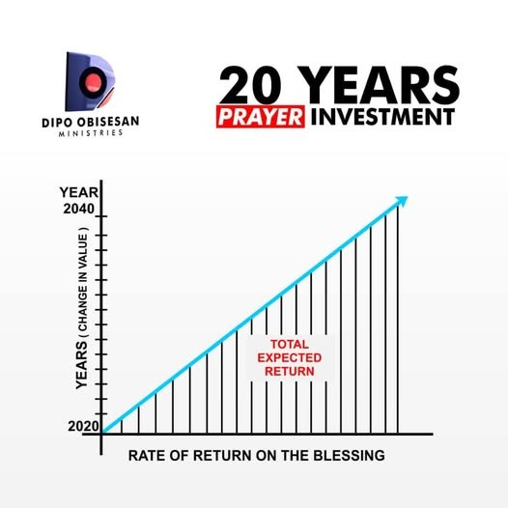

When Isaac was near the end of his life, he spoke a blessing over Jacob:

*“May God give you of the dew of heaven, of the fatness of the earth, and plenty of grain and wine. Let peoples serve you, and nations bow down to you. Be master over your brethren, and let your mother’s sons bow down to you. Cursed be everyone who curses you, and blessed be those who bless you!”*  
— *Genesis 27:28–29*

Jacob left his father’s house with nothing but this blessing. Empty-handed, fleeing for his life, he journeyed to Assyria to live with his uncle Laban. For twenty years, that blessing guided and sustained him. Despite hardship and deceit, God prospered him in every way.

Jacob later testified:  
*“These twenty years I have been with you; your ewes and female goats have not miscarried, and I have not eaten the rams of your flock.”*  
— *Genesis 31:38, 41*

And when he returned home, he declared:  
*“I crossed over this Jordan with my staff, and now I have become two companies.”*  
— *Genesis 32:10*

The blessing turned one man with nothing into a man with nations. **In just 20 years, the blessing made him two companies!**

No investment on earth can match the return of God’s blessing.

For too long, we have focused on breaking generational curses. But the next generation — **Generation Z** and Generation Alpha— is rising to walk in the reality of God’s blessings. It is the blessing that nullifies curses. It is the blessing that preserves destinies and multiplies generations.

**Now is the time to impart generational blessings!**

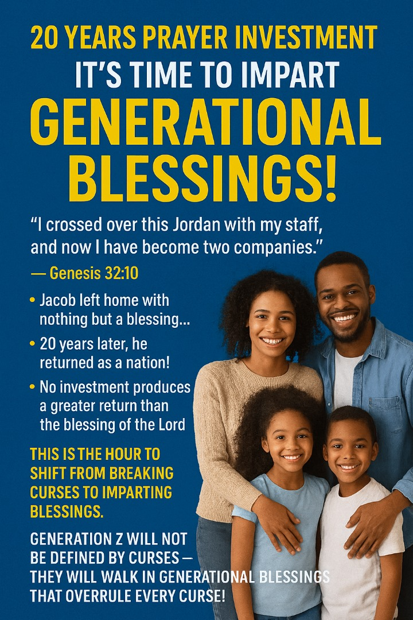

 Register the names of your children through the Vision 2040 link and secure their future in the covenant of blessing.

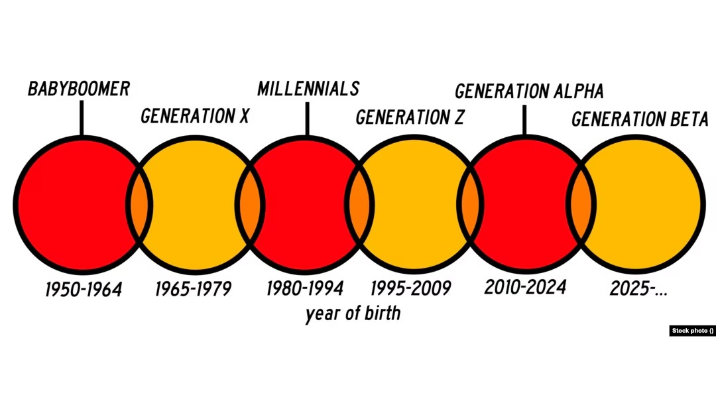

**20 Years of Prayer Investment Form.**

*Family Full Name:

*Email Address:

*Phone Number:

*Country:

Child 1: …………………………………………………………..

Child 2:………………………………………………………….

Child 3:…………………………………………………………..

Child 4:…………………………………………………………..

Child 5:…………………………………………………………..

Special Prayer request:

Create a Box